Tony Hong
1005109482
Sep. 29, 2020

CSC258 Prelab (Lab 2)
Part 2: 4-to-1 Multiplexer
- The full truth table for the 4-to-1 multiplexer would have 2⁶ or 64 rows because there are 6 inputs.
- Schematic of connecting mux2to1 components to build a 4-to-1 multiplexer:
5. Below is a screenshot of a map of my Logisim design of the 4-to-1 Mux onto a DE1-SoC board
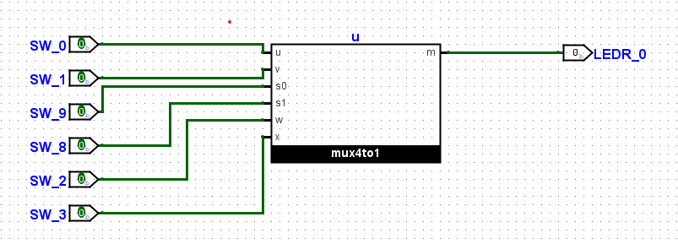

Part 3: 7 Segment Decoder
- Below is the truth table for each of the 7 segments in the decoder with the Karnaugh maps that correspond to each segment which optimize the Boolean expression for each segment.
A | B | C | D | Segment0 | Segment1 | Segment2 | Segment3 | Segment4 | Segment5 | Segment6
0 | 0 | 0 | 0 | 1 | 1 | 1 | 1 | 1 | 1 | 0
0 | 0 | 0 | 1 | 0 | 1 | 1 | 0 | 0 | 0 | 0
0 | 0 | 1 | 0 | 1 | 1 | 0 | 1 | 1 | 0 | 1
0 | 0 | 1 | 1 | 1 | 1 | 1 | 1 | 0 | 0 | 1
0 | 1 | 0 | 0 | 0 | 1 | 1 | 0 | 0 | 1 | 1
0 | 1 | 0 | 1 | 1 | 0 | 1 | 1 | 0 | 1 | 1
0 | 1 | 1 | 0 | 1 | 0 | 1 | 1 | 1 | 1 | 1
0 | 1 | 1 | 1 | 1 | 1 | 1 | 0 | 0 | 0 | 0
1 | 0 | 0 | 0 | 1 | 1 | 1 | 1 | 1 | 1 | 1
1 | 0 | 0 | 1 | 1 | 1 | 1 | 0 | 0 | 1 | 1
1 | 0 | 1 | 0 | 1 | 1 | 1 | 0 | 1 | 1 | 1
1 | 0 | 1 | 1 | 0 | 0 | 1 | 1 | 1 | 1 | 1
1 | 1 | 0 | 0 | 1 | 0 | 0 | 1 | 1 | 1 | 0
1 | 1 | 0 | 1 | 0 | 1 | 1 | 1 | 1 | 0 | 1
1 | 1 | 1 | 0 | 1 | 0 | 0 | 1 | 1 | 1 | 1
1 | 1 | 1 | 1 | 1 | 0 | 0 | 0 | 1 | 1 | 1

- Below are the screenshots of the test vectors for each segment of the decoder.
Segment 0:
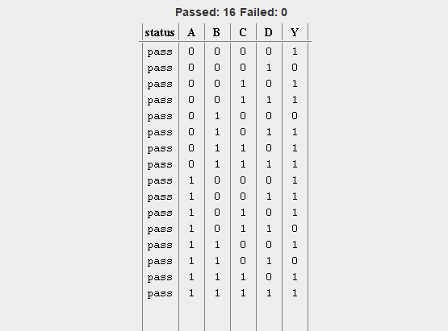
Segment 1:
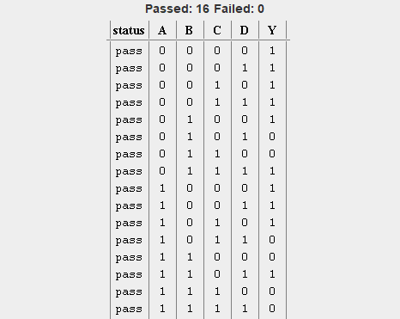
Segment 2:
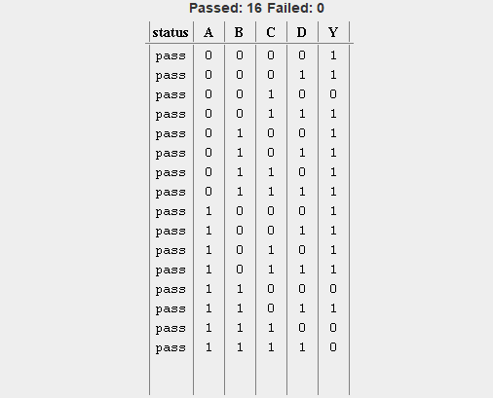
Segment 3:
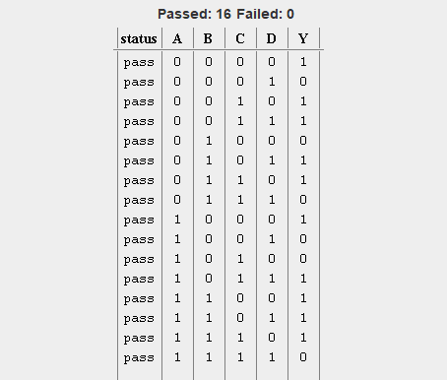
Segment 4:
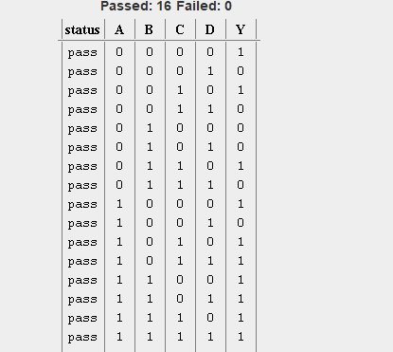
Segment 5:
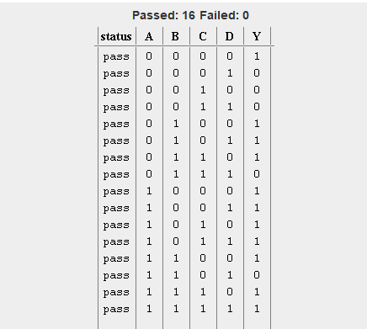

Segment 6:
